Name ______________________________________
Whose Point of View?
Circle the correct character(s). Then take a picture of this page and send it to your ELD Teacher. :)
- I’m green . I want to be pink. | 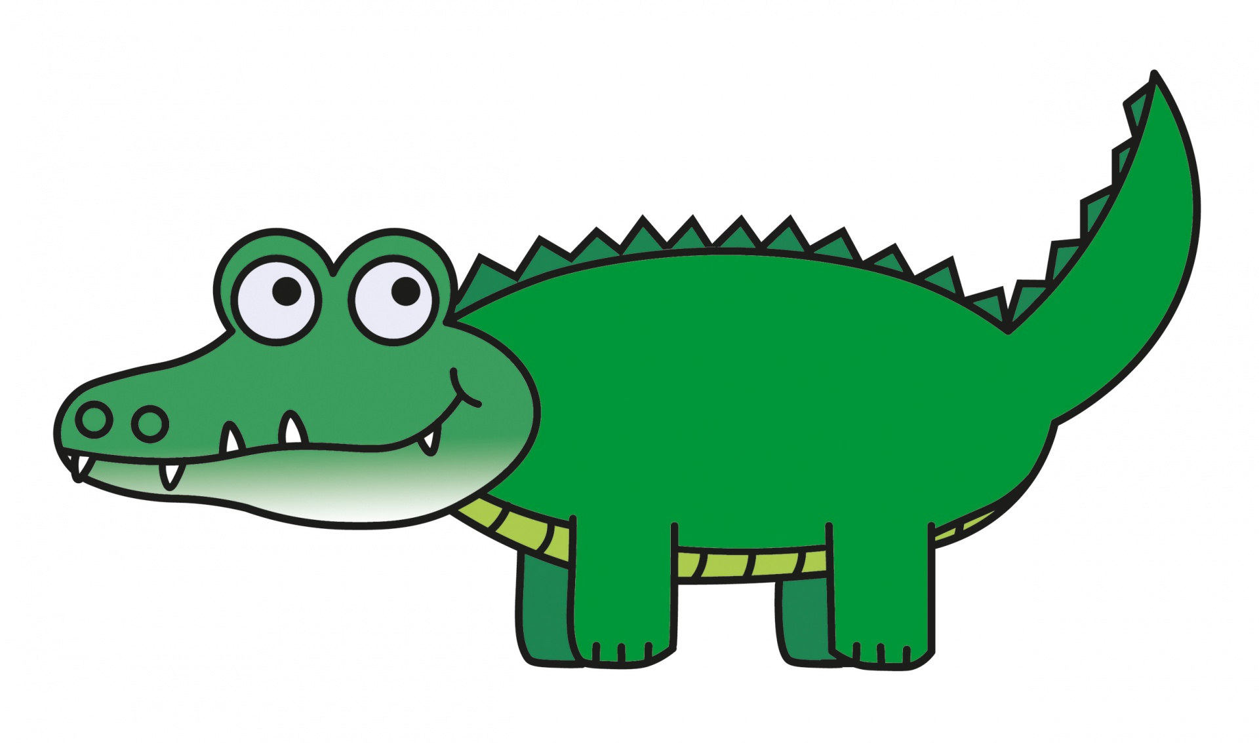  Pete | 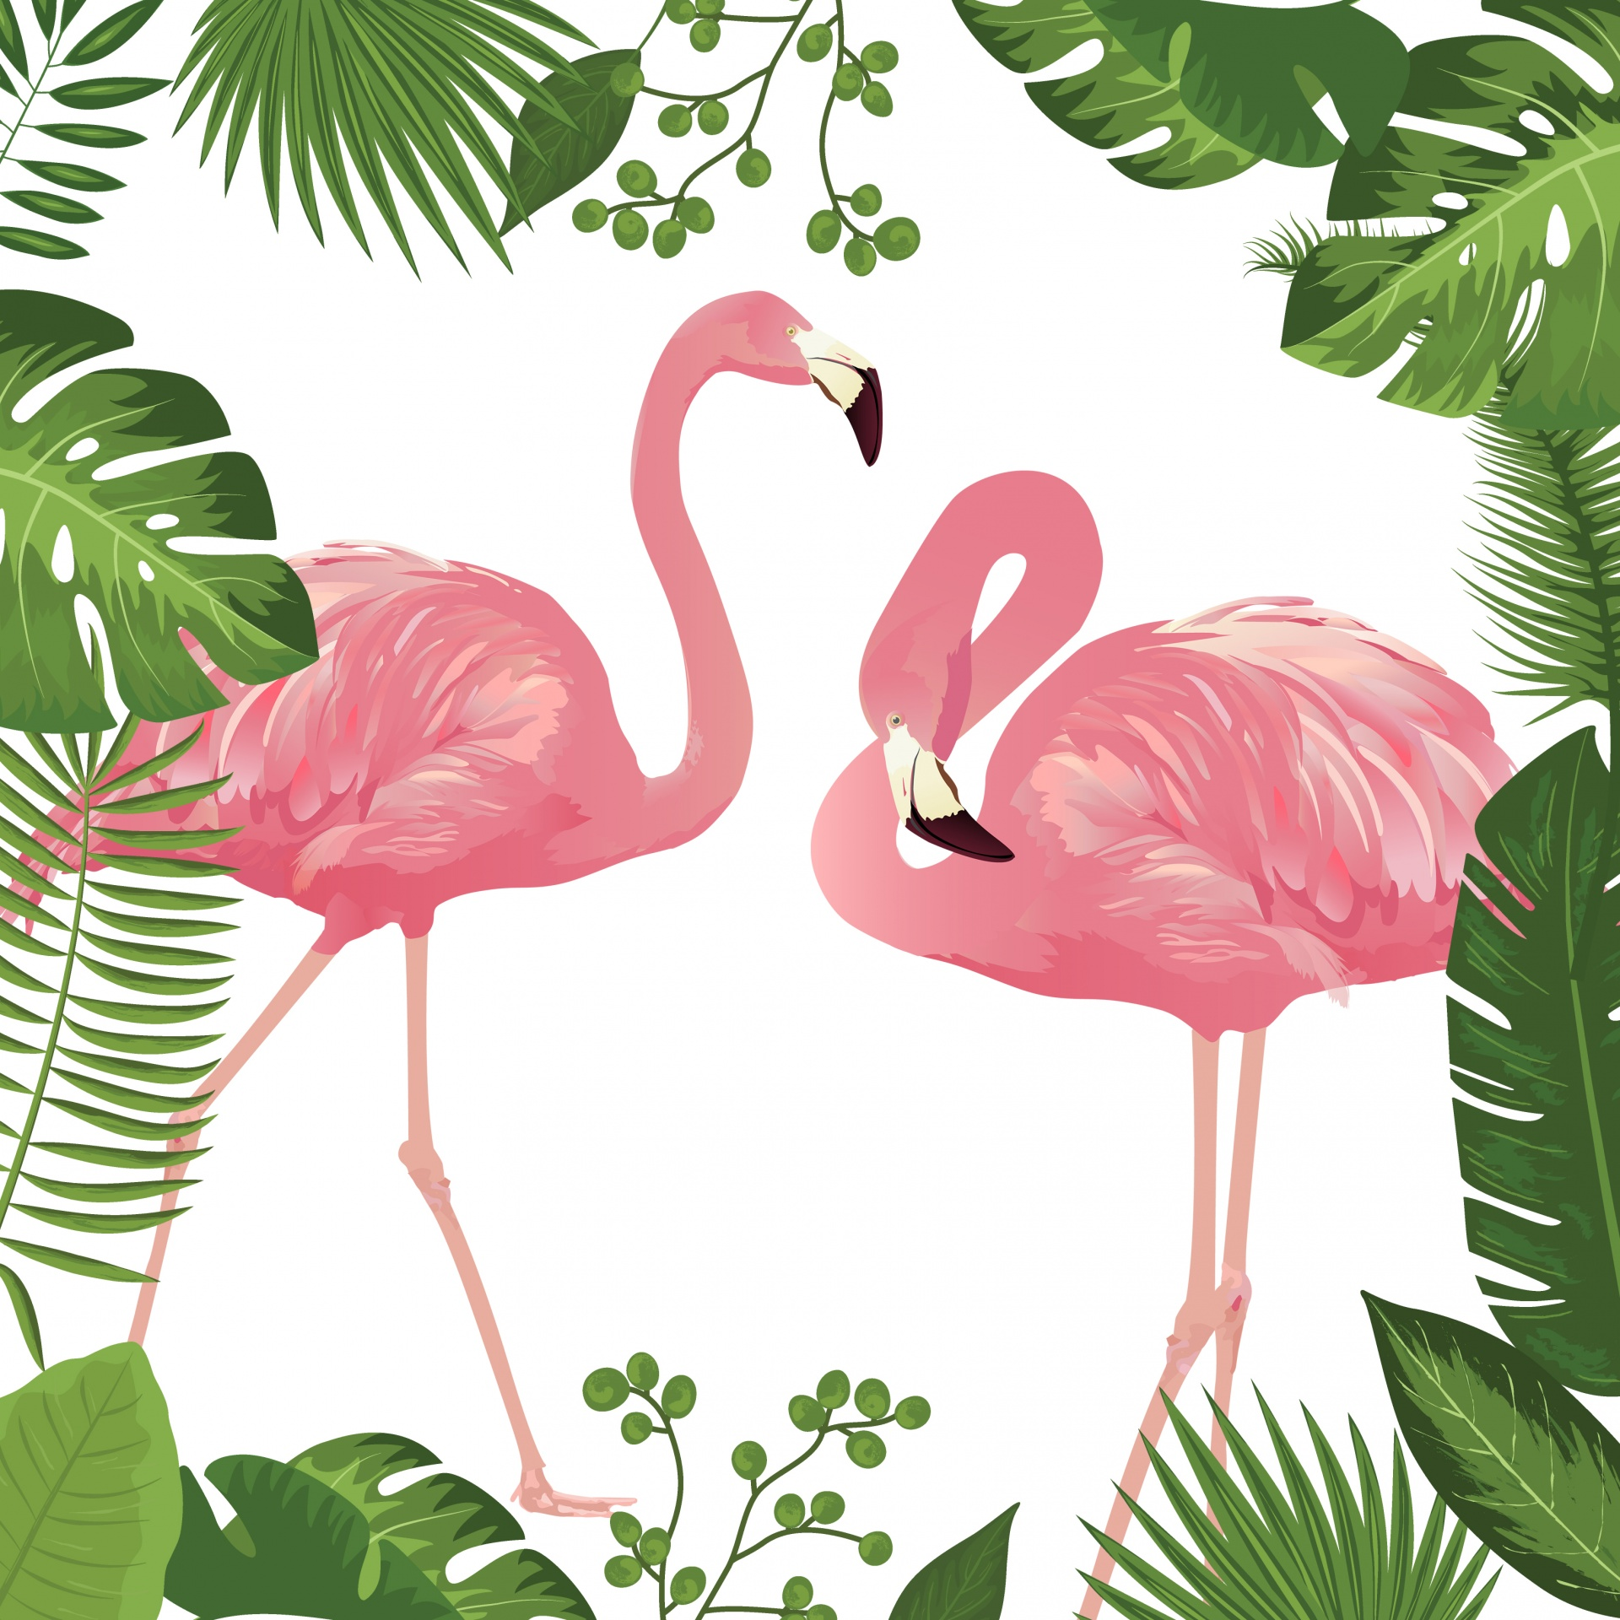  Pete’s Friends
- You are lucky! You have 2 feet and 2 extra feet. ° | Pete | Pete’s Friends
- I have four feet. No one else has four feet. | Pete | Pete’s Friends
- You are getting our feathers wet! | Pete | Pete’s Friends
- You are different, but that is okay! | Pete | Pete’s Friends
For Pete’s Sake: National Geographic 2011

